KASHIPUR MICHEAL MADHUSUDAN MAHAVIDYALAYA

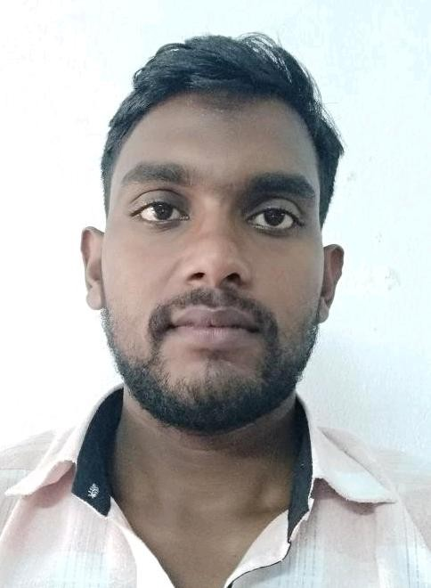
(PERSONAL PROFILE)
Name: SAMRAT MAL
Designation: SACT - I
Department: EDUCATION Date of Joining: 15/07/2016
E-mail: samratmal9@gmail.com

Educational Qualification:
- Graduation: B.A in Education (Hons) 2012
- Post-graduation: M.A in Education 2014
- Ph.D. Pursuing
- NET/SET: NET in education 2019

State Level / National / International Conferences /Seminars /Workshops /Webinar Attended:

Paper Presentations in Seminars (state/ National / International level)
  - One day state level seminar on “Present Crisis in Teaching and learning: Revisiting Pedagogy and Ethics”. Organize by the department of Philosophy and Education Nistarini College purulia 28th September, 2018.
  - One day National seminar on “Restructuring Teacher Education Programe for Conjuring the Spirit of Classroom”. Organize by B.B.M B.Ed. College, Sardaha, Chash, Bokaro, Jharkhand on 19th March 2018.
  - One day National seminar on “Research in Teacher Education in the New Millennium”. Organize by Udyog College of Education in Collaboration with Uttaran College of Education, Onda Bishnupur on 8th April 2018.
  - One day National seminar on “Gandhi Legacy in the 21st Century”. Organize by IQAC and NSS units Mahatma Gandhi College Lalpur, Purulia on 3rd October 2018.
  - Two day National seminar on “Value Education in Respect of Present Education scenario”. Organize by Purnadisha Joychandi Teachers’ training College , Raghunathpur, Purulia on 10th & 11th April 2018,
  - One day International seminar on “Vadu & Traditional Vadra – Culture”. Organize by Kashipur Michael Madhusudan Mahavidyalaya, Panchakote Raj, Purulia on 14th September 2018.
  - One day international seminar on “Indigenous Knowledge and Culture: Issues, Challenges and New Directions”. Organize by IQAC, Gurukul Teachers’ Training Institute, Jiudaru, Kotshila, Purulia on 12th January 2019.
  - ICSSR Sponsored Two day International seminar on “Media, Society and culture: Interrelations and Changing Scenario”. Organize by Kashipur Michael Madhusudan Mahavidyalaya, Panchakote Raj, Purulia on 25th & 26th February 2020.

Participation in Seminars / Conferences / Training Programmes / Workshop / Webinars
  - Workshop on Framing of Semester Based UG Syllabi as per Choice Based Credit System (CBCS)

List of Research Papers published in National / International Journals / Books / Conference Proceedings with ISBN / ISSN / Impact Factor:

Books:
  - Editing Book on “Digitalization in Indian Education System”. (You-tube: A New Horizon of Learning) 2021.

Journals:

QUALITY OF PRIMARY EDUCATION: A STUDY OF PURULIA DISTRICT IN WEST
BENGAL, INDIA. International Journal of Research in Social Sciences Vol. 8 Issue 6, June 2018, ISSN: 2249-2496.
  - Sarak (Shravaka) and Three Temple City of Manbhum- Pakbirra, Telkupi and Deulghata,International journal of basic and applied research, ISSN 2249-3352 (P) 2278- 0505 (E).

A STUDY OF ATTITUDE ON SECONDARY SCHOOL TEACHERS’ TOWARDS ICT
IN PURULIA DISTRICT, Parishodh Journal,Volume IX, Issue III, March/2020 ISSN NO:2347-6648
  - International Journal of Social Science and Humanities Research ISSN 2348-3164 (online) Vol. 8, Issue 1, pp: (356-359), Month: January - March 2020.

ROLE OF TEACHER IN PROMOTING VALUE: A THEORETICAL ANALYSIS,
International Journal of Social Science and Humanities Research ISSN 2348-3164 (online) Vol. 8, Issue 1, pp: (499-501), Month: January - March 2020.

ATTITUDE TOWARDS TO CHOICE BASED CREDIT SYSTEM (CBCS) OF UNDER GRADUATE LEVEL STUDENTS IN HIGHER EDUCATION: A STUDY ON DEGREE COLLEGES UNDER SIDHO-KANHO-BIRSHA UNIVERSITY IN WEST BENGAL,
International Journal of Multi-disciplinary Educational Research, ISSN:2277-7881; Impact factor: 6.514 (2020)
  - Job Satisfaction of Guest Lecturer In Degree Colleges: A Study In Purulia District, Westbengal.IJERMS, ISSN-2394-7659, 2020.

Conference Proceedings:
  - NO

Awards and Recognition:
- NO

Areas of Specialization in Research / Teaching:
  - Specialization in Teaching: Psychological foundation of Education.

  - In Research: Teacher education
Teaching:
    - Theory:
    - Practical:
    - Excursion / Field Survey:
Invited Lecture / Foreign Visit:
NO
Other Academic Activities:

Board of Studies: NO Course Design: NO Paper Setter: NO
Administrative Activities:

Convener of a State level webinar on “Management of Anxiety through Education” organizes by Department of Education in Collaboration with IQAC Kashipur Michael Madhusudan Mahavidyalaya on 26th September 2020.
Associated with Learned Bodies / Association / Society / Organization:

NO

